* Services
  + Vastu shanti (photo and info about the ritual) (info TBD)
  + Satyanarayan (photo and info about the ritual) (infoTBD)
  + Wedding (photo and info about the ritual) (infoTBD)
  + Munja (photo and info about the ritual) (info TBD)
* Downloads
  + Aarti Sets (static) (info TBD)
  + Sahitya List (multiple list based on which pooja to perform) (info TBD)

* Guruji
  + Info about Guruji (info TBD)
* Supporting Services
  + Hair and Makeup (info TBD)
  + Sangeet (info TBD)
  + Food (info TBD)
  + Photographers (info TBD)
* Contact US
  + Email
  + Phone
  + Whatsapp
  + **REACH PANDITJI (GOOD TO HAVE) // NEED TO SEE IF WE CAN SEND INFO TO WHATSAPP PHONE FROM THE SEND MESSAGE**
  + 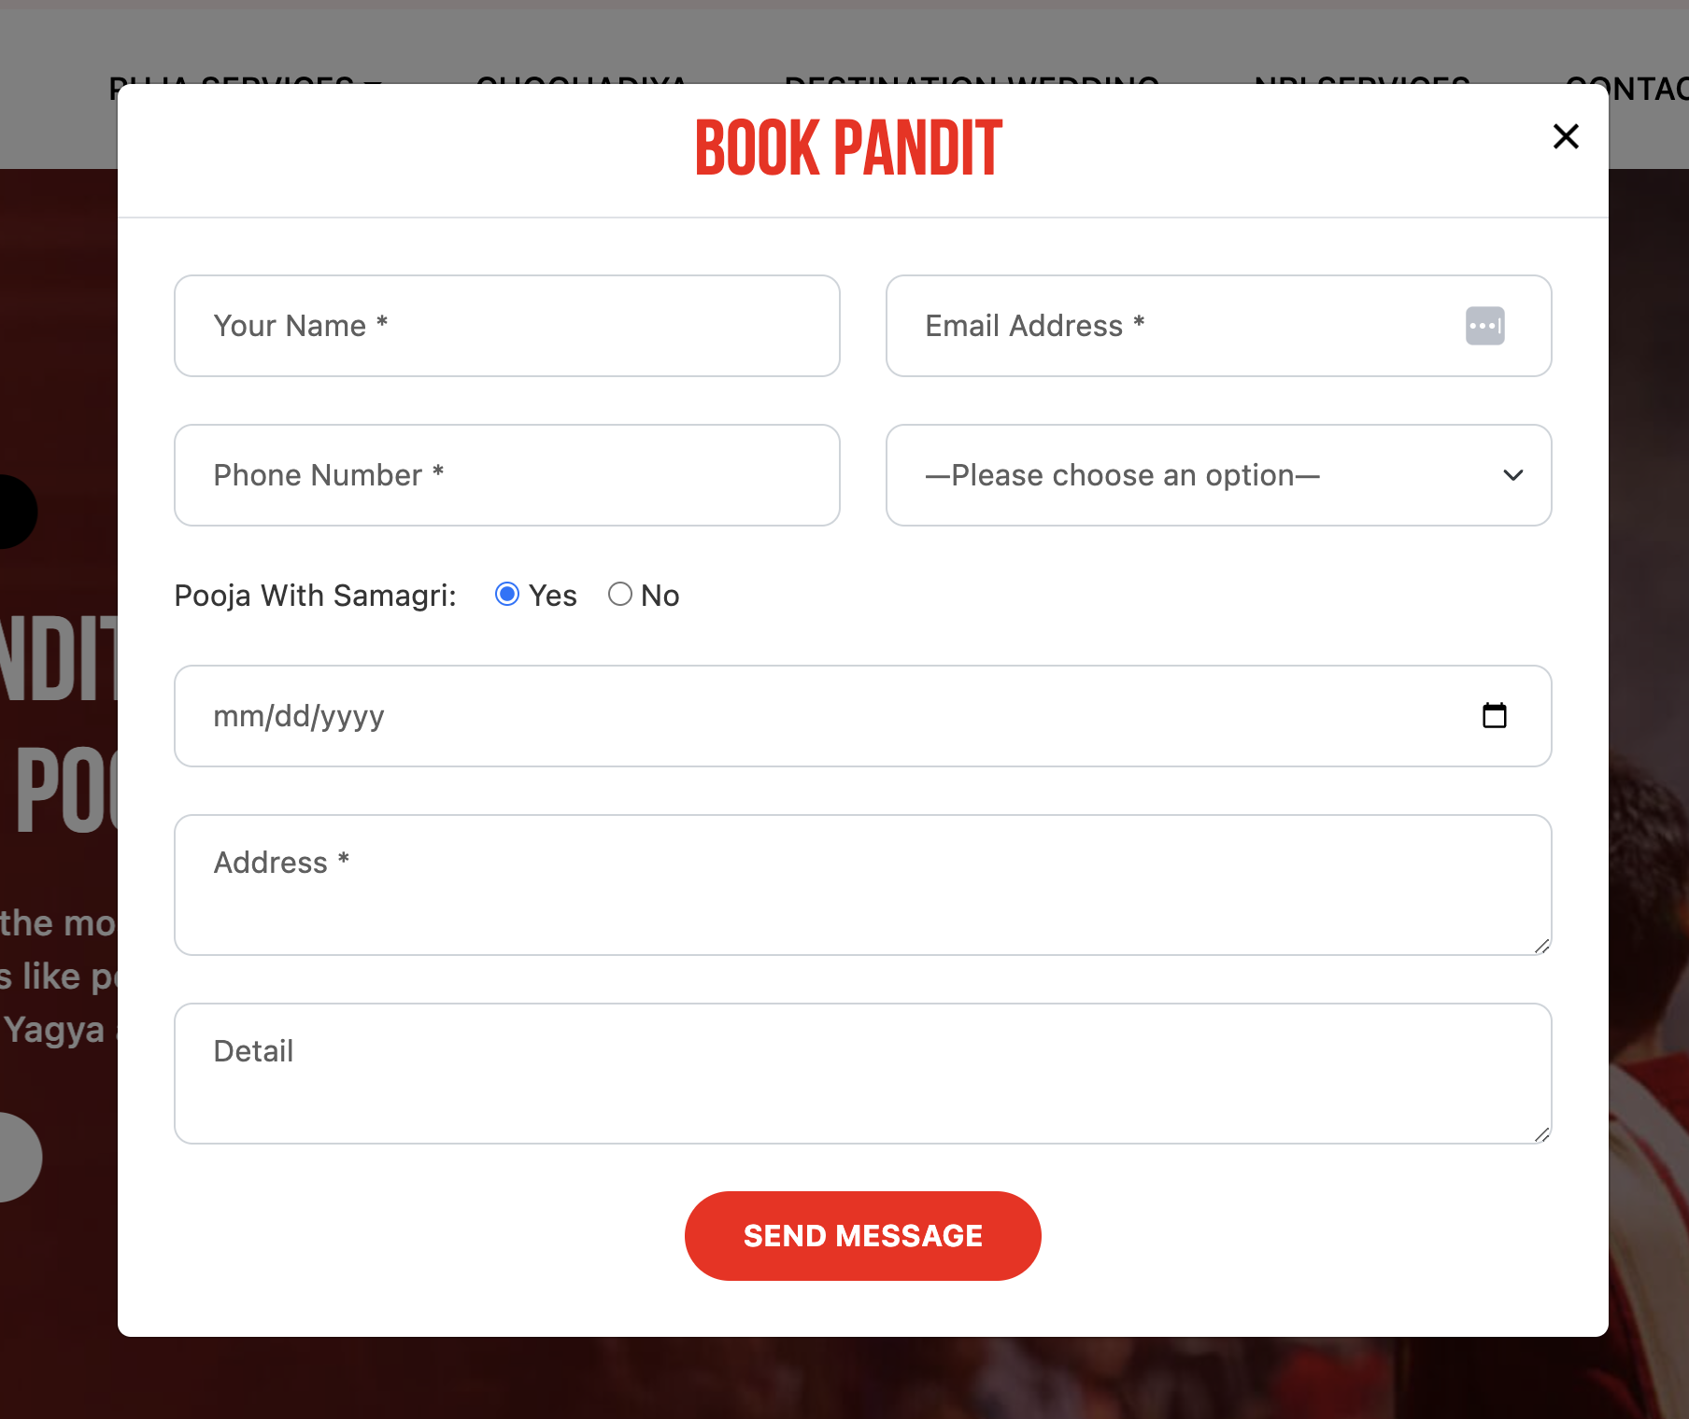
* **BLOGS (ABILITY TO ADD INFO IN FORM OF BLOGS)**

